Deep learning Term Project Final Report

Guo Zikun
2021225559

The code has been uploaded to github:
https://github.com/Gzk738/Term-Project-for-Final-Exam.git
The end of this article has the complete code, if you want to use the code, please use github

This project uses the resnet-18 model
Use cifar-10 for training and test data sets
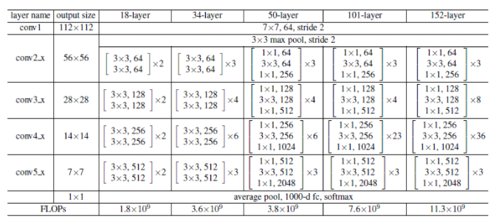

- Data collection (Data enhancement, normalization)
- RandomHorizontalFlip() is the data enhancement function that comes with torchvision, which is used to randomly flip the picture, in addition to RandomGrayscale() for random adjustment of brightness.
- ToTensor() converts image data into tensor tensor. This process includes normalization. Image data is compressed from 0 ~ 255 to 0 ~ 1. This function must be used before Normalize.
- Normalize() is the normalization process. The function of ToTensor() is to convert image data into a tensor between (0,1). Normalize() uses the formula "(x-mean)/std" to convert each The elements are distributed to (-1,1). After normalization, the data is converted to a standard format. This standard format image is invariant to affine transformations such as translation, rotation, and scaling. It is worth noting that after normalization, the stored information and contrast of the image have not changed, but the influence of affine transformation and geometric transformation is reduced, and the gradient descent process is accelerated.
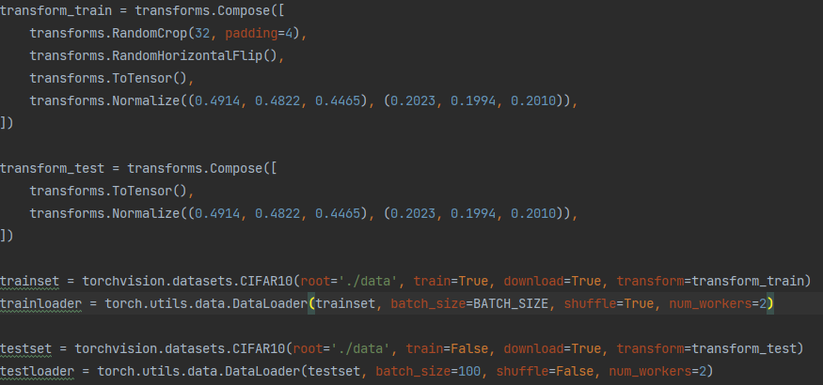
- Model, optimizer
- Criterion generally uses cross entropy in multi-classification situations
- The optimization method is mini-batch momentum-SGD, and uses L2 regularization (weight decay)The scheduler is to adjust the learning rate setting.
- Momentum=0.9, weight decay=5e-4
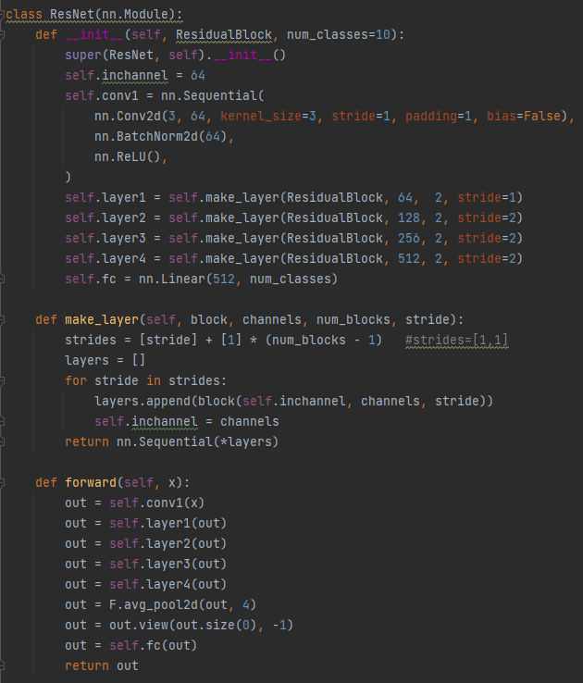

- Training
- optimizer.zero_grad() is used to clear the gradient. Every time a new gradient is applied, the original gradient must be cleared, otherwise the gradient will accumulate.
- loss.backward(), backpropagation, pytorch will automatically calculate the value of backpropagation.
- optimizer.step(), after backpropagation, the objective function will be adjusted
- scheduler.step(), update the learning rate, according to your preset value step_size, the learning rate will be gamma attenuated after every step_size epoch. Note that this should be at the end of the epoch cycle, otherwise the learning rate will be updated one epoch earlier during training.
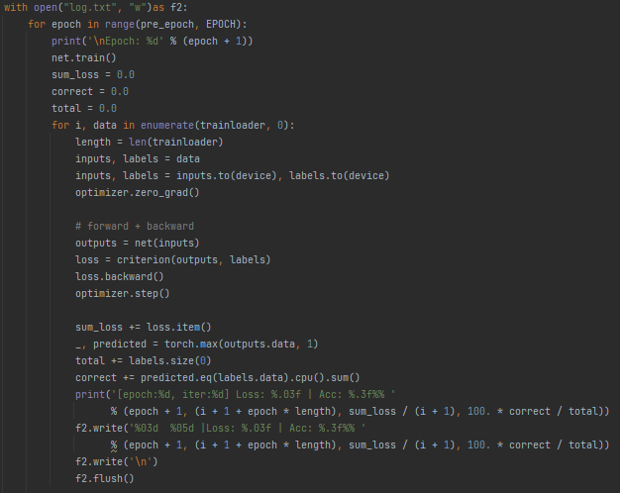

- Test
The selected data set is Cifar-10. The data set has a total of 60,000 colored images with labels. These images are 32*32 in size and are divided into 10 categories, each with 6000 images. There are 50000 sheets for training, 5000 sheets for each class, and another 10000 sheets for testing, 1000 sheets for each class. The learning rate is artificially modified during training, when epoch: [1-135], lr=0.1; epoch: [136-185], lr=0.01; epoch: [186-240], lr=0.001. The training code is as follows:
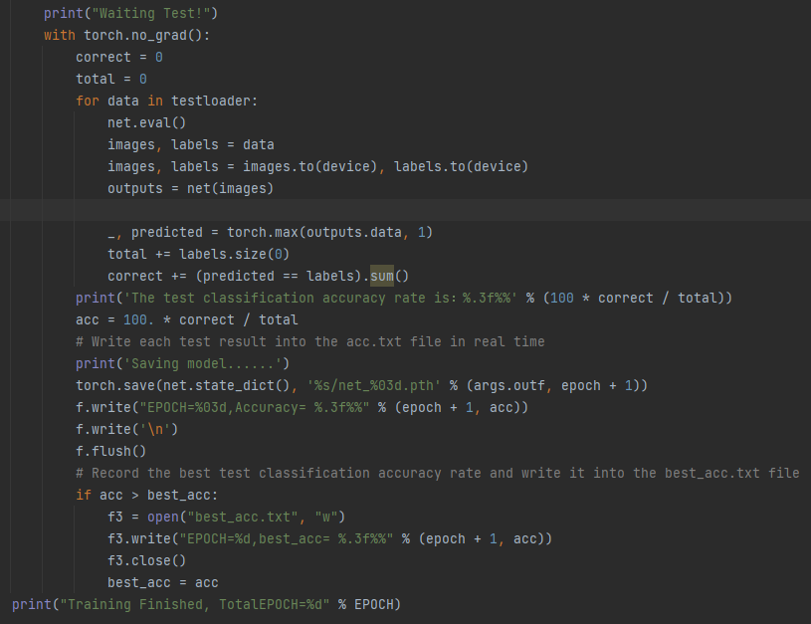
- Result
Record the output value of the loss function in each epoch and output the graph
- model.eval(), since the training set does not require gradient update, it enters the test mode.
- with torch.no_grad(), check whether the test mode has been turned on, and enter the test if it is turned on.

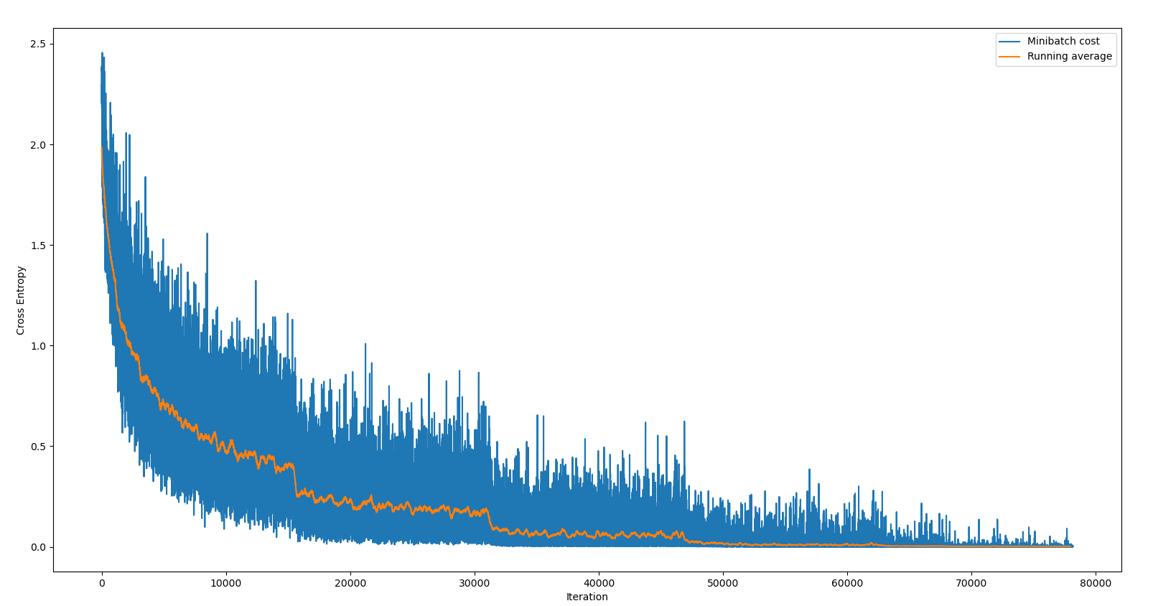
Loss reduction graph
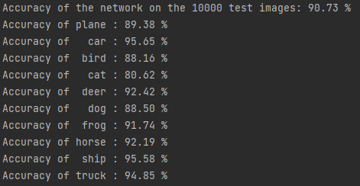
The overall accuracy rate and the accuracy rate of each category.

import torch
import torch.nn as nn
import torch.optim as optim
import torchvision
import torchvision.transforms as transforms
import argparse
from resnet import ResNet18
import os
device = torch.device("cuda" if torch.cuda.is_available() else "cpu")
parser = argparse.ArgumentParser(description='PyTorch CIFAR10 Training')
parser.add_argument('--outf', default='./model/', help='folder to output images and model checkpoints')
args = parser.parse_args()
EPOCH = 135
pre_epoch = 0
BATCH_SIZE = 128
LR = 0.01
transform_train = transforms.Compose([
transforms.RandomCrop(32, padding=4),
transforms.RandomHorizontalFlip(),
transforms.ToTensor(),
transforms.Normalize((0.4914, 0.4822, 0.4465), (0.2023, 0.1994, 0.2010)),
])
transform_test = transforms.Compose([
transforms.ToTensor(),
transforms.Normalize((0.4914, 0.4822, 0.4465), (0.2023, 0.1994, 0.2010)),
])
trainset = torchvision.datasets.CIFAR10(root='./data', train=True, download=True, transform=transform_train)
trainloader = torch.utils.data.DataLoader(trainset, batch_size=BATCH_SIZE, shuffle=True, num_workers=2)
testset = torchvision.datasets.CIFAR10(root='./data', train=False, download=True, transform=transform_test)
testloader = torch.utils.data.DataLoader(testset, batch_size=100, shuffle=False, num_workers=2)
# Cifar-10的标签
classes = ('plane', 'car', 'bird', 'cat', 'deer', 'dog', 'frog', 'horse', 'ship', 'truck')
net = ResNet18().to(device)
criterion = nn.CrossEntropyLoss()
optimizer = optim.SGD(net.parameters(), lr=LR, momentum=0.9, weight_decay=5e-4)
if __name__ == "__main__":
if not os.path.exists(args.outf):
os.makedirs(args.outf)
best_acc = 85
print("Start Training, Resnet-18!")
with open("acc.txt", "w") as f:
with open("log.txt", "w")as f2:
for epoch in range(pre_epoch, EPOCH):
print('\nEpoch: %d' % (epoch + 1))
net.train()
sum_loss = 0.0
correct = 0.0
total = 0.0
for i, data in enumerate(trainloader, 0):
length = len(trainloader)
inputs, labels = data
inputs, labels = inputs.to(device), labels.to(device)
optimizer.zero_grad()
# forward + backward
outputs = net(inputs)
loss = criterion(outputs, labels)
loss.backward()
optimizer.step()
sum_loss += loss.item()
_, predicted = torch.max(outputs.data, 1)
total += labels.size(0)
correct += predicted.eq(labels.data).cpu().sum()
print('[epoch:%d, iter:%d] Loss: %.03f | Acc: %.3f%% '
% (epoch + 1, (i + 1 + epoch * length), sum_loss / (i + 1), 100. * correct / total))
f2.write('%03d %05d |Loss: %.03f | Acc: %.3f%% '
% (epoch + 1, (i + 1 + epoch * length), sum_loss / (i + 1), 100. * correct / total))
f2.write('\n')
f2.flush()
# Test the accuracy after each training epoch
print("Waiting Test!")
with torch.no_grad():
correct = 0
total = 0
for data in testloader:
net.eval()
images, labels = data
images, labels = images.to(device), labels.to(device)
outputs = net(images)
_, predicted = torch.max(outputs.data, 1)
total += labels.size(0)
correct += (predicted == labels).sum()
print('The test classification accuracy rate is：%.3f%%' % (100 * correct / total))
acc = 100. * correct / total
# Write each test result into the acc.txt file in real time
print('Saving model......')
torch.save(net.state_dict(), '%s/net_%03d.pth' % (args.outf, epoch + 1))
f.write("EPOCH=%03d,Accuracy= %.3f%%" % (epoch + 1, acc))
f.write('\n')
f.flush()
# Record the best test classification accuracy rate and write it into the best_acc.txt file
if acc > best_acc:
f3 = open("best_acc.txt", "w")
f3.write("EPOCH=%d,best_acc= %.3f%%" % (epoch + 1, acc))
f3.close()
best_acc = acc
print("Training Finished, TotalEPOCH=%d" % EPOCH)

'''ResNet-18 Image classfication for cifar-10 with PyTorch
Author 'Sun-qian'.
'''
import torch
import torch.nn as nn
import torch.nn.functional as F
class ResidualBlock(nn.Module):
def __init__(self, inchannel, outchannel, stride=1):
super(ResidualBlock, self).__init__()
self.left = nn.Sequential(
nn.Conv2d(inchannel, outchannel, kernel_size=3, stride=stride, padding=1, bias=False),
nn.BatchNorm2d(outchannel),
nn.ReLU(inplace=True),
nn.Conv2d(outchannel, outchannel, kernel_size=3, stride=1, padding=1, bias=False),
nn.BatchNorm2d(outchannel)
)
self.shortcut = nn.Sequential()
if stride != 1 or inchannel != outchannel:
self.shortcut = nn.Sequential(
nn.Conv2d(inchannel, outchannel, kernel_size=1, stride=stride, bias=False),
nn.BatchNorm2d(outchannel)
)
def forward(self, x):
out = self.left(x)
out += self.shortcut(x)
out = F.relu(out)
return out
class ResNet(nn.Module):
def __init__(self, ResidualBlock, num_classes=10):
super(ResNet, self).__init__()
self.inchannel = 64
self.conv1 = nn.Sequential(
nn.Conv2d(3, 64, kernel_size=3, stride=1, padding=1, bias=False),
nn.BatchNorm2d(64),
nn.ReLU(),
)
self.layer1 = self.make_layer(ResidualBlock, 64, 2, stride=1)
self.layer2 = self.make_layer(ResidualBlock, 128, 2, stride=2)
self.layer3 = self.make_layer(ResidualBlock, 256, 2, stride=2)
self.layer4 = self.make_layer(ResidualBlock, 512, 2, stride=2)
self.fc = nn.Linear(512, num_classes)
def make_layer(self, block, channels, num_blocks, stride):
strides = [stride] + [1] * (num_blocks - 1) #strides=[1,1]
layers = []
for stride in strides:
layers.append(block(self.inchannel, channels, stride))
self.inchannel = channels
return nn.Sequential(*layers)
def forward(self, x):
out = self.conv1(x)
out = self.layer1(out)
out = self.layer2(out)
out = self.layer3(out)
out = self.layer4(out)
out = F.avg_pool2d(out, 4)
out = out.view(out.size(0), -1)
out = self.fc(out)
return out
def ResNet18():
return ResNet(ResidualBlock)

